UNIT-1
World Wide Web

What is World Wide Web?
World Wide Web, which is also known as a Web, is a collection of websites or web pages stored in web servers and connected to local computers through the internet. These websites contain text pages, digital images, audios, videos, etc. Users can access the content of these sites from any part of the world over the internet using their devices such as computers, laptops, cell phones, etc. The WWW, along with internet, enables the retrieval and display of text and media to your device.

WEB PAGES
web page is a document available on world wide web. Web Pages are stored on web server and can be viewed using a web browser.
A web page can cotain huge information including text, graphics, audio, video and hyper links. These hyper links are the link to other web pages.
Collection of linked web pages on a web server is known as website. There is unique Uniform Resource Locator (URL) is associated with each web page.
The building blocks of the Web are web pages which are formatted in HTML and connected by links called "hypertext" or hyperlinks and accessed by HTTP. These links are electronic connections that link related pieces of information so that users can access the desired information quickly. Hypertext offers the advantage to select a word or phrase from text and thus to access other pages that provide additional information related to that word or phrase.
A web page is given an online address called a Uniform Resource Locator (URL). A particular collection of web pages that belong to a specific URL is called a website, e.g., www.facebook.com, www.google.com, etc. So, the World Wide Web is like a huge electronic book whose pages are stored on multiple servers across the world.
Small websites store all of their WebPages on a single server, but big websites or organizations place their WebPages on different servers in different countries so that when users of a country search their site they could get the information quickly from the nearest server.

Types of Web Pages

→Static Web page
Static web pages are also known as flat or stationary web page. They are loaded on the client’s browser as exactly they are stored on the web server. Such web pages contain only static information. User can only read the information but can’t do any modification or interact with the information.
Static web pages are created using only HTML. Static web pages are only used when the information is no more required to be modified.
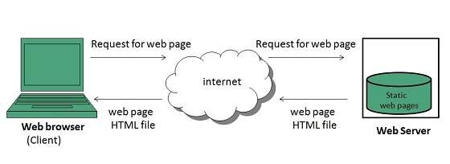

→Dynamic Web page
Dynamic web page shows different information at different point of time. It is possible to change a portaion of a web page without loading the entire web page. It has been made possible using Ajax technology.

Server-side dynamic web page
It is created by using server-side scripting. There are server-side scripting parameters that determine how to assemble a new web page which also include setting up of more client-side processing.

Client-side dynamic web page
It is processed using client side scripting such as JavaScript. And then passed in to Document Object Model (DOM).
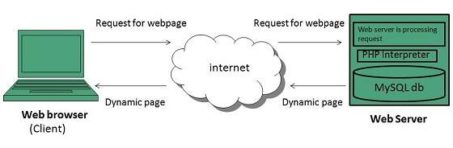
What is Website?
Website is the collection of web pages, different multimedia content such as text, images, and videos which can be accessed by the URL which you can see in the address bar of the browser. For example: https://www.geeksforgeeks.org
How to access Websites?
When we type a certain URL in a browser search bar, the browser requests the page from the Web server and the Web server returns the required web page and its content to the browser. Now, it differs how the server returns the information required in the case of static and dynamic websites.
Types of Website:
- Static Website
- Dynamic Website

Static Website: In Static Websites, Web pages are returned by the server which are prebuilt source code files built using simple languages such as HTML, CSS, or JavaScript. There is no processing of content on the server (according to the user) in Static Websites. Web pages are returned by the server with no change therefore, static Websites are fast. There is no interaction with databases. Also, they are less costly as the host does not need to support server-side processing with different languages.
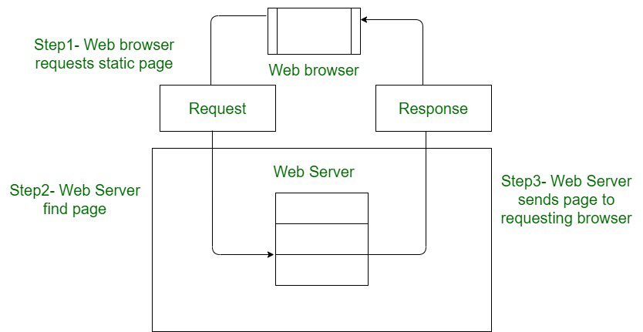
Architecture of Static Website
Note: Static does not mean that it will not respond to user actions, These Websites are called static because these cannot be manipulated on the server or interact with databases (which is the case in Dynamic Websites).

Dynamic Website: In Dynamic Websites, Web pages are returned by the server which are processed during runtime means they are not prebuilt web pages but they are built during runtime according to the user’s demand with the help of server-side scripting languages such as PHP, Node.js, ASP.NET and many more supported by the server. So, they are slower than static websites but updates and interaction with databases are possible.
Dynamic Websites are used over Static Websites as updates can be done very easily as compared to static websites (Where altering in every page is required) but in Dynamic Websites, it is possible to do a common change once and it will reflect in all the web pages.
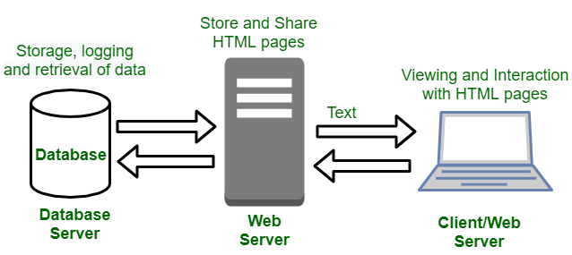
Architecture of Dynamic Website

Client Server Computing

Client/Server is a term used to describe a computing model for the development of computerized systems. This model is based on the distribution of functions between two types of independent and autonomous processors: servers and clients. A client is any process that requests specific services from server processes. A server is a process that provides requested services for clients. Client and server processes can reside in the same computer or in different computers connected by a network.
In client server computing, the clients requests a resource and the server provides that resource. A server may serve multiple clients at the same time while a client is in contact with only one server. Both the client and server usually communicate via a computer network but sometimes they may reside in the same system.
An illustration of the client server system is given as follows −
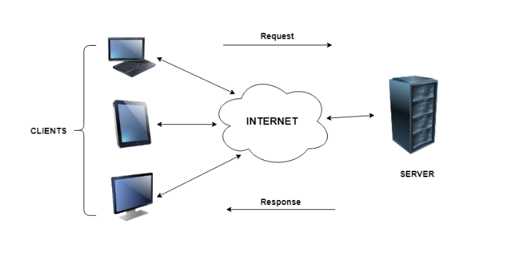

Client Server Communication

Categories of Client-Server Computing
There are four main categories of client-server computing:
- One-Tier architecture: consists of a simple program running on a single computer without requiring access to the network. User requests don’t manage any network protocols, therefore the code is simple and the network is relieved of the extra traffic.
- Two-Tier architecture: consists of the client, the server, and the protocol that links the two tiers. The Graphical User Interface code resides on the client host and the domain logic resides on the server host. The client-server GUI is written in high-level languages such as C++ and Java.

- Three-Tier architecture: consists of a presentation tier, which is the User Interface layer, the application tier, which is the service layer that performs detailed processing, and the data tier, which consists of a database server that stores information.
- N-Tier architecture: divides an application into logical layers, which separate responsibilities and manage dependencies, and physical tiers, which run on separate machines, improve scalability, and add latency from the additional network communication. N-Tier architecture can be closed-layer, in which a layer can only communicate with the next layer down, or open-layer, in which a layer can communicate with any layers below it.
Microsoft MySQL Server is a popular example of a three-tier architecture, consisting of three major components: a protocol layer, a relational engine, and a storage engine. Any client machines that connect directly to SQL Server must have a SQL Server client installed. Microsoft’s Client-Server Runtime Process helps manage the majority of the graphical instruction sets on Windows operating system.

What is a Web Client?
A Web client is an application installed on the user’s device that they can use to surf the internet. Web clients request computer servers for a webpage but don’t store them.
Without these clients, an ordinary user can’t use the internet. When you search for a particular webpage through your browser, it retrieves the page from the appropriate server and displays the result. The client and server communicate via HTTP(Hypertext Transfer Protocol).

Features of Web Clients
These days, all web browsers offer some standard features which aim to make internet browsing easier for us. In short, your choice of web client should feature some of the following.
- Support for private/incognito browsing.
- VPN or Proxy support.
- Multiple tabs or windows.
- Back/Previous and Forward buttons.
- Home, Refresh, Stop buttons.
- Address bar for URL.
- History and bookmark.

How Web Client Works with Web Server Applications
Web clients can’t do much on their own. The information they display on your screen, like this article, is powered by web servers. So, how does your client work with web server applications?
Well, the Web server applications include a range of software that provide features like sending and receiving client requests, processing data on the fly and displaying them in the correct order. These applications communicate with your server via the HTTP protocol. However, some servers also use other protocols.
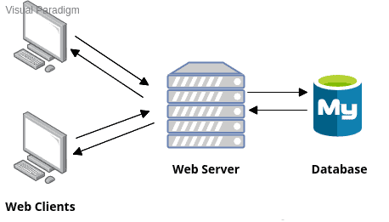
When you send a web request to a page, one of these server applications handles your request. It checks if the request made by the client software is valid and whether the requested information is available on the server or not. Once confirmed, the web server application processes the request and sends the desired information to the web client.

What is a Web Server?
Firstly, a Web Servers are systems that are connected to the internet and store web pages. In addition it sends out requested data over the web using HTTP. In nutshell, like Apache– the Web Servers are just like libraries for web pages. They store, process and deliver the web resources to the client software.

Features of Web Servers
As the powerhouse of the internet, the web server is responsible for hosting documents and processing them. Modern web servers feature the following common functionalities:
- Support for standard protocols like HTTP, FTP, SMTP, and SSH.
- Can serve static content as requested.
- Also they can deliver dynamic content on demand.
- Logging client information and requests.
- Support for virtual hosting.
- Ability to authorize or deny website path traversal.
- Support for large files, bandwidth throttling, and custom error pages.

Client Side and server side Scripting Languages
The scripts may be created in two ways: on the client side or the server side, where the server-side scripts are processed on a server. In contrast, client-side scripting needs browsers to execute scripts on the client system but doesn't connect with the server executing the client-side scripts.

What is Server-side Scripting?
Server-side scripting is a programming technique for creating code that may run software on the server side. In other words, server-side scripting is any scripting method that may operate on a web server. At the server end, actions such as website customization, dynamic changes in website content, response creation to user requests, database access, and many more are carried out.
Server-side scripting creates a communication channel between a server and a client. Previously, CGI (Common Gateway Interface) scripts were used to implement server-side scripting, and CGI was created to execute scripts written in computer languages such as C++ or Perl on websites.
The server-side is made up of three parts: the database, the server, the APIs, and the backend web software written in the server-side scripting language. When a browser requests a page with server-side scripting, the web server evaluates the script before delivering the page to the browser. In this case, script processing may entail collecting information from a database, performing simple computations, or selecting the relevant material to be shown on the client end. The output is provided to the web browser when the script is processed. The web server hides the scripts from the end user until the content is delivered, making the data and source code safer.

Server-side scripting languages
There are various server-side scripting languages. Some main server-side scripting languages are as follows:
Python
It is an open-source language that is very powerful and easy to learn. It is suitable for beginners because it is simple to learn and read. It is believed to be used by Google and YouTube. It is a OOPs language with dynamic typing and data structures. It has grown to be one of the most popular languages for both quick application development and web development.
PHP
It is an open-source server-side scripting programming language mainly designed for web apps and is the most utilized scripting language. It allows you to retrieve and manipulate data from a database and is utilized along with SQL to query the database. It is a fast and simple language to learn and develop, and Facebook, Wikipedia, and WordPress utilize it.
Ruby
It is a free and open-source programming language that was developed and firstly introduced in the early 1990s. It is a dynamic language that is simple to read and write and an OOPs language that is interpreted as it runs. It has evolved continuously since its development and is one of the most utilized web development languages.

Features of Server-side Scripting
There are various features of server-side scripting. Some main features of the server-side scripting are as follows:
- It is connected with data access, error handling, and data processing speed.
- It is processed and interacts with the server.
- Using a highly integrated programming language makes it more secure than client-side scripting.

What is Client-side Scripting?
Client-side scripting generates code that may be executed on the client end without needing server-side processing. These scripts are typically embedded into HTML text. Client-side scripting may be utilized to check the user's form for problems before submitting it and to change the content based on the user input. The web needs three components to function: client, database, and server.
The client-side scripting may significantly reduce server demand. It is intended to be utilized as a scripting language with a web browser as the host program. The HTML and CSS are delivered as plain text when a user uses a browser to request a webpage from the server, and the browser understands and renders the web content at the client end.

Client-side Scripting Languages
There are various client-side scripting languages. Some main client-side scripting languages are as follows:
HTML
t is not a scripting language; it is a markup language. However, it serves as the basic language for client-side web development, also referred to as front-end. The presence of hypertext on a page denotes its hyperlinks. The markup language uses tags to define the structure and layout. It is a programming language that is mainly used to design a web page's structure and layout.
CSS
CSS is an abbreviation for Cascading Style Sheets. It provides a technique for creating graphic elements that help a web application's appearance look more appealing. A style tag in a web page defines all the specifics regarding the web page's presentation, including its border styles, image styles, colour, font styles, borders, format, font size, margins, padding, etc.
JavaScript
It is a client-side scripting language designed for a specific purpose, but several JavaScript frameworks are already utilized as server-side scripting technologies.
VBScript
VBScript is based on Visual Basic, which was created by Microsoft in 1996. It is a scripting programming language that is lightweight, fast, and easy to learn. It is not a OOPs language but is similar to JavaScript.
*Note: The client-side programming languages are HTML, CSS, and JavaScript. In contrast, server-side scripting programming languages, including PHP, ColdFusion, Python, ASP.net, Java, C++, Ruby, C#,
Difference between client-side scripting and server-side scripting :
Client-side scripting | Server-side scripting
Source code is visible to the user. | Source code is not visible to the user because its output  of server-sideside is an HTML page.
Its main function is to provide the requested output to the end user. | Its primary function is to manipulate and provide access to the respective database as per the request.
It usually depends on the browser and its version. | In this any server-side technology can be used and it does not  depend on the client.
It runs on the user’s computer. | It runs on the web server.
There are many advantages linked with this like faster.  response times, a more interactive application. | The primary advantage is its ability to highly customize, response  requirements, access rights based on user.
It does not provide security for data. | It provides more security for data.
It is a technique used in web development in which scripts run on the client’s browser. | It is a technique that uses scripts on the web server to produce a response that is customized for each client’s request.
HTML, CSS, and javascript are used. | PHP, Python, Java, Ruby are used.
No need of interaction with the server. | It is all about interacting with the servers.
It reduces load on processing unit of the server. | It surge the processing load on the server.

HTML Introduction
HTML stands for HyperText Markup Language. It is used to design web pages using a markup language. HTML is the combination of Hypertext and Markup language. Hypertext defines the link between web pages. A markup language is used to define the text document within the tag which defines the structure of web pages. This language is used to annotate (make notes for the computer) text so that a machine can understand it and manipulate text accordingly. Most markup languages (e.g. HTML) are human-readable. The language uses tags to define what manipulation has to be done on the text.
HTML is a markup language used by the browser to manipulate text, images, and other content, in order to display it in the required format. HTML was created by Tim Berners-Lee in 1991. The first-ever version of HTML was HTML 1.0, but the first standard version was HTML 2.0, published in 1995.
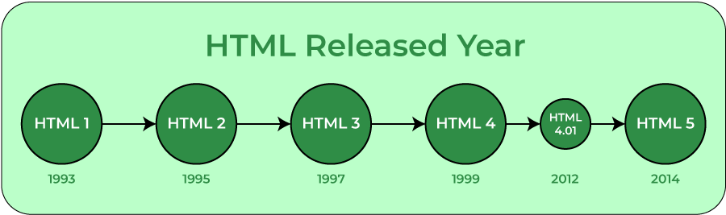
Elements and Tags: HTML uses predefined tags and elements which tell the browser how to properly display the content. Remember to include closing tags. If omitted, the browser applies the effect of the opening tag until the end of the page.
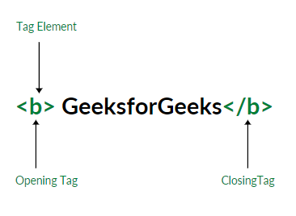
HTML page structure: The basic structure of an HTML page is laid out below. It contains the essential building-block elements (i.e. doctype declaration, HTML, head, title, and body elements) upon which all web pages are created.
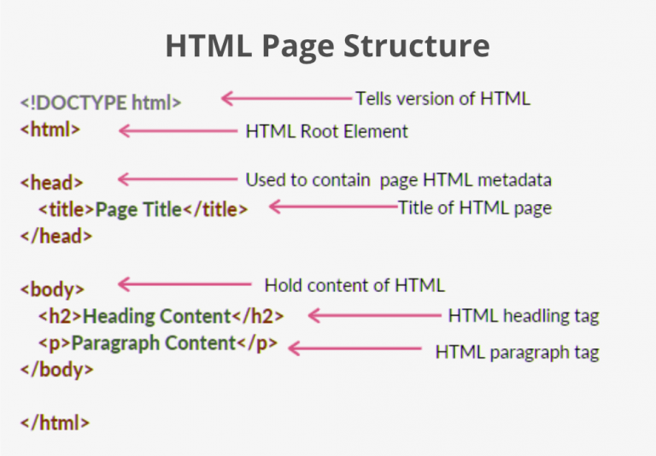<!DOCTYPE html>: This is the document type declaration (not technically a tag). It declares a document as being an HTML document. The doctype declaration is not case-sensitive.
<html>: This is called the HTML root element. All other elements are contained within it.
<head>: The head tag contains the “behind the scenes” elements for a webpage. Elements within the head aren’t visible on the front-end of a webpage. HTML elements used inside the <head> element include:
- <style>-This html tag allows us to insert styling into our webpages and make them appealing to look at with the help of CSS.
- <title>-The title is what is displayed on the top of your browser when you visit awebsite and contains title of the webpage that you are viewing.
- <base>-It specifies the base URL for all relative URL’s in a document.
- <noscript>– Defines a section of HTML that is inserted when the scripting has been turned off in the users browser.
- <script>-This tag is used to add functionality in the website with the help of JavaScript.
- <meta>-This tag encloses the meta data of the website that must be loaded every time the website is visited. For eg:- the metadata charset allows you to use the standard UTF-8 encoding in your website. This in turn allows the users to view your webpage in the language of their choice. It is a self closing tag.
- <link>– The ‘link’ tag is used to tie together HTML, CSS and JavaScript. It is self closing.
- <body>: The body tag is used to enclose all the visible content of a webpage. In other words, the body content is what the browser will show on the front-end.
- An HTML document can be created using any text editor. Save the text file using .html or .htm. Once saved as an HTML document, the file can be opened as a webpage in the browser.
Features of HTML:
- It is easy to learn and easy to use.
- It is platform-independent.
- Images, videos, and audio can be added to a web page.
- Hypertext can be added to the text.
- It is a markup language.
Why learn HTML?
- It is a simple markup language. Its implementation is easy.
- It is used to create a website.
- Helps in developing fundamentals about web programming.
- Boost professional career.
Advantages:
- HTML is used to build websites.
- It is supported by all browsers.
- It can be integrated with other languages like CSS, JavaScript, etc.
Disadvantages:
- HTML can only create static web pages. For dynamic web pages, other languages have to be used.
- A large amount of code has to be written to create a simple web page.
- The security feature is not good.

HTML Comments
HTML comments are not displayed in the browser, but they can help document your HTML source code.

HTML Comment Tag
You can add comments to your HTML source by using the following syntax:
<!-- Write your comments here -->
Notice that there is an exclamation point (!) in the start tag, but not in the end tag.

Add Comments
With comments you can place notifications and reminders in your HTML code:

Example
<!-- This is a comment -->
<p>This is a paragraph.</p>
<!-- Remember to add more information here -->

Hide Inline Content
Comments can be used to hide parts in the middle of the HTML code.

Example
Hide a part of a paragaph:
<!DOCTYPE html>
<html>
<body>
<p>This <!-- great text --> is a paragraph.</p>
</body>
</html>
Output
This is a paragraph.

Special Characters in HTML
There are times when it becomes necessary to display symbols or special characters in HTML that are not available on a standard keyboard, such as ©. You may also need to display special characters in HTML that have a special meaning in HTML (<,>,&, etc). To accomplish this, HTML uses the Special Character Entity tag.
To add special characters in HTML, type an ampersand (&), followed by the pound sign (#), followed by the number of the code, and ended with a semicolon (;). For example, the © (copyright) symbol can be displayed by using &#169;. There are literally hundreds of special character entities currently available. A few of the more common tags are listed in the table below.
Description | Special Character | Code
Acute Accent | ´ | &#180;
Ampersand | & | &#38;
Cent Sign | ¢ | &#162;
Copyright | © | &#169;
Dagger | † | &#8224;
Degree Sign | ° | &#186;
Division Sign | ÷ | &#247;
Euro | € | &#8363;
Fraction (one-half) | ½ | &#189;
Fraction (one-fourth) | ¼ | &#188;
Fraction (three-fourths) | ¾ | &#190;
Greater-than sign | > | &#62;
Left-angle quote | « | &#171;
Less-than sign | < | &#60;
Multiply sign | x | &#215;
Plus or minus sign | ± | &#177;
Quotation Mark (left) | “ | &#8220;
Quotation Mark (right) | ” | &#8221;
Registered Trademark | ® | &#174;
Right-angel quote | » | &#187;
Superscript one | ¹ | &#185;
Trademark | ™ | &#8482;
Example:
<!DOCTYPE html>
<html>
<body bgcolor="lightblue">
<p>This is a sample paragraph.</p>
<hr>
An example of copyright symbol &#169;
<br>
An example of Registered Trademark symbol &#174;
<br>
An example of Trademark symbol &#8482;
<hr>
<p>This is a closing paragraph for display purposes</p>
</body>
</html>
Output
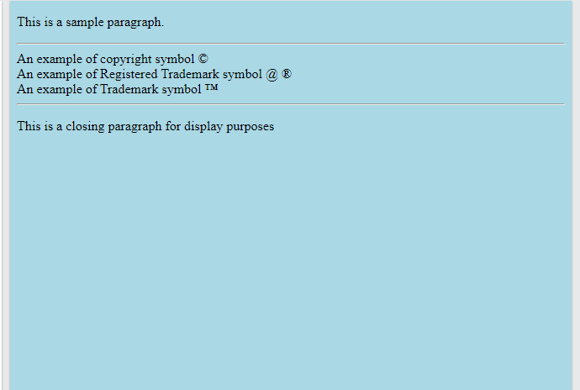

HTML Text Formatting
HTML contains several elements for defining text with a special meaning.

HTML Formatting Elements
Formatting elements were designed to display special types of text:

HTML Text Formatting Elements
Tag | Description
<b> | Defines bold text
<em> | Defines emphasized text
<i> | Defines a part of text in an alternate voice or mood
<small> | Defines smaller text
<strong> | Defines important text
<sub> | Defines subscripted text
<sup> | Defines superscripted text
<ins> | Defines inserted text
<del> | Defines deleted text
<mark> | Defines marked/highlighted text

HTML <mark> Element:
The HTML <mark> element defines text that should be marked or highlighted:
<!DOCTYPE html>
<html>
<body>
<p>Do not forget to buy <mark>milk</mark> today.</p>
</body>
</html>

Output
Do not forget to buy milk today.

HTML <del> Element
The HTML <del> element defines text that has been deleted from a document. Browsers will usually strike a line through deleted text:
<!DOCTYPE html>
<html>
<body>
<p>My favorite color is <del>blue</del> red.</p>
</body>
</html>

Output
My favorite color is red.

HTML <ins> Element
The HTML <ins> element defines a text that has been inserted into a document. Browsers will usually underline inserted text:
<!DOCTYPE html>
<html>
<body>
<p>My favorite color is <del>blue</del> <ins>red</ins>.</p>
</body>
</html>
Output
My favorite color is red.

HTML Anchor
The HTML anchor tag defines a hyperlink that links one page to another page. It can create hyperlink to other web page as well as files, location, or any URL. The "href" attribute is the most important attribute of the HTML a tag. and which links to destination page or URL.

href attribute of HTML anchor tag
The href attribute is used to define the address of the file to be linked. In other words, it points out the destination page.

The syntax of HTML anchor tag is given below.
<a href = "..........."> Link Text </a>

Let's see an example of HTML anchor tag.
<a href="second.html">Click for Second Page</a>

Specify a location for Link using target attribute
If we want to open that link to another page then we can use target attribute of <a> tag. With the help of this link will be open in next page.

Example:
<!DOCTYPE html>
<html>
<head>
<title></title>
</head>
<body>
<p>Click on <a href="https://www.javatpoint.com/" target="_blank"> this-link </a>to go on home page of JavaTpoint.</p>
</body>
</html>

Output:

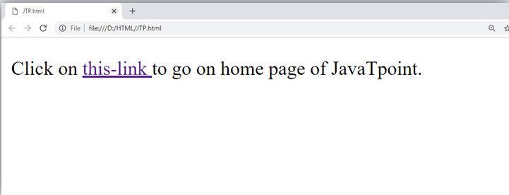
Note:
- The target attribute can only use with href attribute in anchor tag.
- If we will not use target attribute then link will open in same page.

Appearance of HTML anchor tag
An unvisited link is displayed underlined and blue.
A visited link displayed underlined and purple.
An active link is underlined and red.

Adding images and sound in html

→Adding Images

HTML Images Syntax: The HTML <img> tag is used to embed an image in a web page.
Images are not technically inserted into a web page; images are linked to web pages. The <img> tag creates a holding space for the referenced image.
The <img> tag is empty, it contains attributes only, and does not have a closing tag.
The <img> tag has two required attributes:
- src - Specifies the path to the image
- alt - Specifies an alternate text for the image

Syntax
<img src="url" alt="alternatetext">

The src Attribute: The required src attribute specifies the path (URL) to the image.
Note: When a web page loads, it is the browser, at that moment, that gets the image from a web server and inserts it into the page. Therefore, make sure that the image actually stays in the same spot in relation to the web page, otherwise your visitors will get a broken link icon. The broken link icon and the alt text are shown if the browser cannot find the image.

The alt Attribute: The required alt attribute provides an alternate text for an image, if the user for some reason cannot view it (because of slow connection, an error in the src attribute, or if the user uses a screen reader).

Example
<img src="wrongname.gif" alt="Flowers in Chania">

Image Size - Width and Height
You can use the style attribute to specify the width and height of an image.

Example
<img src="img_girl.jpg" alt="Girl in a jacket" style="width:500px;height:600px;">

*Image as a Link
To use an image as a link, put the <img> tag inside the <a> tag:

Example
<a href="default.asp">
<img src="smiley.gif" alt="HTML tutorial" style="width:42px;height:42px;">
</a>
→Adding sound in html
→ Adding Sound
Sometimes we need to add music or video into your web page. The easiest way to add video or sound to your web site is to include the special HTML tag called <embed>. This tag causes the browser itself to include controls for the multimedia automatically provided browser supports <embed> tag and given media type.
You can also include a <noembed> tag for the browsers which don't recognize the <embed> tag. You could, for example, use <embed> to display a movie of your choice, and <noembed> to display a single JPG image if browser does not support <embed> tag.
Here is a simple example to play an embedded midi file −
<!DOCTYPE html>
<html>

<head>
<title>HTML embed Tag</title>
</head>

<body>
<embed src = "/html/yourfile.mid" width = "100%" height = "60" >
<noembed><img src = "yourimage.gif" alt = "Alternative Media" ></noembed>
</embed>
</body>

</html>

The <embed> Tag Attributes
Following is the list of important attributes which can be used with <embed> tag.
Note −The align and autostart attributes deprecated in HTML5. Do not use these attributes.
Sr.No | Attribute & Description
1 | align  Determines how to align the object. It can be set to either center, left or right.
2 | autostart  This boolean attribute indicates if the media should start automatically. You can set it either true or false.
3 | loop  Specifies if the sound should be played continuously (set loop to true), a certain number of times (a positive value) or not at all (false)
4 | playcount  Specifies the number of times to play the sound. This is alternate option for loop if you are usiong IE.
5 | hidden  Specifies if the multimedia object should be shown on the page. A false value means no and true values means yes.
6 | width  Width of the object in pixels
7 | height  Height of the object in pixels
8 | name  A name used to reference the object.
9 | src  URL of the object to be embedded.
10 | volume  Controls volume of the sound. Can be from 0 (off) to 100 (full volume).

Background Audio
We can use HTML <bgsound> tag to play a soundtrack in the background of your webpage. This tag is supported by Internet Explorer only and most of the other browsers ignore this tag. It downloads and plays an audio file when the host document is first downloaded by the user and displayed. The background sound file also will replay whenever the user refreshes the browser.
Note − The bgsound tag is deprecated and it is supposed to be removed in a future version of HTML. So they should not be used rather, it's suggested to use HTML5 tag audio for adding sound. This tag is having only two attributes loop and src. Both these attributes have same meaning as explained above.
Here is a simple example to play a small midi file −
<!DOCTYPE html>
<html>
<head>
<title>HTML embed Tag</title>
</head>
<body>
<bgsound src = "/html/yourfile.mid">
<noembed><img src = "yourimage.gif" ></noembed>
</bgsound>
</body>

</html>
This will produce the blank screen. This tag does not display any component and remains hidden.
Internet Explorer can also handle only three different sound format files − wav, the native format for PCs; au, the native format for most Unix workstations; and MIDI, a universal music-encoding scheme.

Frames and Floating Frames

HTML | <frame> Tag
HTML Frames are used to divide the web browser window into multiple sections where each section can be loaded separately. A frameset tag is the collection of frames in the browser window.
Creating Frames: Instead of using body tag, use frameset tag in HTML to use frames in web browser. But this Tag is deprecated in HTML 5. The frameset tag is used to define how to divide the browser. Each frame is indicated by frame tag and it basically defines which HTML document shall open into the frame. To define the horizontal frames use row attribute of frame tag in HTML document and to define the vertical frames use col attribute of frame tag in HTML document.

Attributes of Frameset tag:
- cols: The cols attribute is used to create vertical frames in web browser. This attribute is basically used to define the no of columns and its size inside the frameset tag.
The size or width of the column is set in the frameset in the following ways:
→Use absolute value in pixel
Example: <frameset cols = "300, 400, 300">
→Use percentage value
Example: <frameset cols = "30%, 40%, 30%">
→Use wild card values:
Example: <frameset cols = "30%, *, 30%">
In the above example * will take the remaining percentage for creating vertical frame.
- rows: The rows attribute is used to create horizontal frames in web browser. This attribute is used to define no of rows and its size inside the frameset tag.
The size of rows or height of each row use the following ways:
→Use absolute value in pixel
Example: <frameset rows = "300, 400, 300">
→Use percentage value
Example: <frameset rows = "30%, 40%, 30%">
→Use wild card values
Example: <frameset rows = "30%, *, 30%">
In the above example * will take the remaining percentage for creating horizontal frame.

- border: This attribute of frameset tag defines the width of border of each frames in pixels. Zero value is used for no border.
Example:
<frameset border="4" frameset>
- frameborder: This attribute of frameset tag is used to specify whether the three-dimensional border should be displayed between the frames or not for this use two values 0 and 1, where 0 defines for no border and value 1 signifies for yes there will be border.
- framespacing: This attribute of frameset tag is used to specify the amount of spacing between the frames in a frameset. This can take any integer value as an parameter which basically denotes the value in pixel.
Example:
- <framespacing="20">
It means there will be 20 pixel spacing between the frames
Attributes of Frame Tag:
*name: This attribute is used to give names to the frame. It differentiate one frame from another. It is also used to indicate which frame a document should loaded into. Example:
<frame name = "top" src = "C:/Users/dharam/Desktop/attr1.png" />
*src: This attribute in frame tag is basically used to define the source file that should be loaded into the frame.The value of src can be any url.
Example:
<frame name = "left" src = "/html/left.htm" />
*marginwidth: This attribute in frame tag is used to specify width of the spaces in pixels between the border and contents of left and right frame.
Example:
<frame marginwidth="20">
*marginheight: This attribute in frame tag is used to specify height of the spaces in pixels between the border and contents of top and bottom frame.
Example:
<frame marginheight="20">
*scrollbar: To control the appearance of scroll bar in frame use scrollbar attribute in frame tag. This is basically used to control the appearance of scrollbar. The value of this attribute can be yes, no, auto. Where the value no denotes there will be no appearance of scroll bar.
Example:
<frame scrollbar="no">
Advantages:
  - It allows the user to view multiple documents within a single Web page.
  - It load pages from different servers in a single frameset.
  - The older browsers that do not support frames can be addressed using the tag.
Disadvantages: Due to some of its disadvantage it is rarely used in web browser.
  - Frames can make the production of website complicated.
  - A user is unable to bookmark any of the Web pages viewed within a frame.
  - The browser’s back button might not work as the user hopes.
  - The use of too many frames can put a high workload on the server.
  - Many old web browser doesn’t support frames.
Note: This tag is not supported in HTML5.
EXAMPLE1:
<html>
<head>
<title>Example of HTML Frames using row attribute</title>
</head>
<frameset rows = "20%, 60%, 20%">
<frame name = "top" src =
"C:/Users/dharam/Desktop/attr1.png" />
<frame name = "main" src =
"C:/Users/dharam/Desktop/gradient3.png" />
<frame name = "bottom" src =
"C:/Users/dharam/Desktop/col_last.png" />
<noframes>
<body>The browser you are working does
not support frames.</body>
</noframes>
</frameset>
</html>

Output: The above example basically used to create three horizontal frames: top, middle and bottom using row attribute of frameset tag and the noframe tag is used for those browser who doesn’t support noframe.
EXAMPLE2:
<html>
<head>
<title>Example of HTML Frames Using col Attribute</title>
</head>
<frameset cols = "30%, 40%, 30%">
<frame name = "top" src =
"C:/Users/dharam/Desktop/attr1.png" />
<frame name = "main" src =
"C:/Users/dharam/Desktop/gradient3.png" />
<frame name = "bottom" src =
"C:/Users/dharam/Desktop/col_last.png" />
<noframes>
<body>The browser you are working does
not support frames.</body>
</noframes>
</frameset>
</html>

Output: The above example basically used to create three vertical frames: left, center and right using col attribute of frameset tag.

Here is a simple frame document:
<!DOCTYPE HTML PUBLIC "-//W3C//DTD HTML 4.01 Frameset//EN"
"http://www.w3.org/TR/html4/frameset.dtd">
<HTML>
<HEAD>
<TITLE>A simple frameset document</TITLE>
</HEAD>
<FRAMESET cols="20%, 80%">
<FRAMESET rows="100, 200">
<FRAME src="contents_of_frame1.html">
<FRAME src="contents_of_frame2.gif">
</FRAMESET>
<FRAME src="contents_of_frame3.html">
<NOFRAMES>
<P>This frameset document contains:
<UL>
<LI><A href="contents_of_frame1.html">Some neat contents</A>
<LI><IMG src="contents_of_frame2.gif" alt="A neat image">
<LI><A href="contents_of_frame3.html">Some other neat contents</A>
</UL>
</NOFRAMES>
</FRAMESET>
</HTML>
that might create a frame layout something like this:
---------------------------------------
| | |
| | |
| Frame 1 | |
| | |
| | |
|---------| |
| | Frame 3 |
| | |
| | |
| | |
| Frame 2 | |
| | |
| | |
| | |
| | |
---------------------------------------
If the user agent can't display frames or is configured not to, it will render the contents of the NOFRAMES element.

Inline (Floating) Frames
Inline Frame or an iframe is allows us to open new pages inside main pages. Inline frames are also referred to as Floating frames. <iframe> .. </iframe> tag is used to create inline or floating frame.
Note: Netscape navigator, version 4 or older does not support iframes. If the browser doesn't support iframe then it won't be visible.
Attributes of <iFrame> tag :
name: used to set a name for the iframe.
src: Specifies the url of the document to be loaded into the iframe.
Width: used to specify the width of the iframe.
Height: used to specify the height of the iframe.
Frameborder: used to specify the whether to have a border for the iframe or not. This attribute possibly takes two values. i.e, 1 for on and 0 for off.
Scrolling: used to specify whether the iframe should have scrolling capability or not. This attribute possibly takes two values i.e, 1 for on and 0 for off.
vspace: used to leave gaps on the top and bottom of the iframe. This attribute is similar to cellspacing attribute of a table tag.
hspace: used to leave gaps on the sides of the iframe. This attribute is similar to cellpadding attribute of a table tag.
marginwidth: used to specify the number of pixels to be left as the left/right margins.
marginheight: used to specify the number of pixels to be left as the top/bottom margins.
Example:
<iframe name="iname" src="targetpg.html"></iframe>
Placing an inline frame is similar to placing an image on a page. As shown in the following code, within the
<html>
<head>
<title>
IFRAMES</title>
</head>
<body bgcolor="black" text="white">
<h1><b>INLINE(FLOATING) FRAMES</b></h1>
<iframe src="scrolly.html" width=300 height= 200 align="left" hspace=12></iframe>
<p>Microsoft IE 3.0 has introduced the concept of iframe to implement floating frames...</p>
</body>
</html>
Output
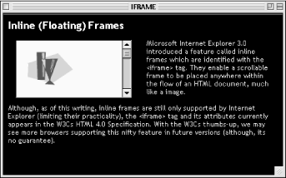
Developing Forms in HTML
What is HTML Form :
HTML Form is a document that stores information of a user on a web server using interactive controls. An HTML form contains different kinds of information such as username, password, contact number, email id, etc.
The elements used in an HTML form are the check box, input box, radio buttons, submit buttons, etc. Using these elements the information of a user is submitted on a web server.
The form tag is used to create an HTML form.
Input Element in HTML Forms :
Input Elements are the most common elements which are used in HTML Forms. Various user input fields can be created such as text field, check box, password field, radio button, submit button, etc. The most common input elements are listed below:
Text Field in HTML Forms :
The text field is a one-line input field allowing the user to input text. Text Field input controls are created using the “input” element with a type attribute having the value as “text”.
<html>
<body>
<h3>Example Of Text Field</h3>
<form>
<label for="EMAIL ID">Email Id:</label><br>
<input type="text" name="Email id" id="Email id">
</form>
</body>
</html>

- Number Field in HTML Forms:
This field is used to take numbers as input.

<html>
<body>
<h3>Example Of Number Field</h3>
<form>
<label for="Age">Age:</label><br>
<input type="number" name="Age" id="Age">
</form>
</body>
</html>

- Password Field in HTML Forms :
Password fields are a type of text field in which the text entered is masked using asterisks or dots for the prevention of user identity from another person who is looking at the screen. Password Field input controls are created using the “input” element with a type attribute having the value as “password”.

<html>
<body>
<h3>Example of Password Field</h3>
<form>
<label for="user-password">Password:
</label><br>
<input type="password" name="user-pwd"
id="user-password">
</form>
</body>
</html>

- Radio Buttons in HTML Form :
Radio Buttons are used to let the user select exactly one option from a list of predefined options. Radio Button input controls are created using the “input” element with a type attribute having the value as “radio”.

<html>
<body>
<h3>Example of Radio Buttons</h3>
<form>
SELECT GENDER
<br>
<input type="radio" name="gender" id="male">
<label for="male">Male</label><br>
<input type="radio" name="gender" id="female">
<label for="female">Female</label>
</form>
</body>
</html>

- Checkboxes in HTML Form :
Checkboxes are used to let the user select one or more options from a pre-defined set of options. Checkbox input controls are created using the “input” element with a type attribute having the value as “checkbox”.

<html>
<body>
<h3>Example of HTML Checkboxes</h3>
<form>
<b>SELECT SUBJECTS</b>
<br>
<input type="checkbox" name="subject" id="maths">
<label for="maths">Maths</label>
<input type="checkbox" name="subject" id="science">
<label for="science">Science</label>
<input type="checkbox" name="subject" id="english">
<label for="english">English</label>
</form>
</body>
</html>

- File select boxes in HTML Forms :
File select boxes are used to allow the user to select a local file and send it as an attachment to the web server. It is similar to a text box with a button that allows the user to browse for a file. Instead of browsing for the file, the path and the name of the file can also be written. File select boxes are created using the “input” element with a type attribute having the value as “file”.

<html>
<body>
<h3>Example of a File Select Box</h3>
<form>
<label for="fileselect">Upload:</label>
<input type="file" name="upload" id="fileselect">
</form>
</body>
</html>

- Text area in an HTML Form :
Text Area is a multiple-line text input control that allows the user to provide a description or text in multiple lines. A Text Area input control is created using the “textarea” element.

<html>
<body>
<h3>Example of a Text Area Box</h3>
<form>
<label for="Description">Description:</label>
<textarea rows="5" cols="50" name="Description"
id="Description"></textarea>
</form>
</body>
</html>

- Select Boxes in HTML Forms :
Select boxes are used to allow users to select one or more than one option from a pull-down list of options. Select boxes are created using two elements which are “select” and “option”. List items are defined within the select element.

<html>
<body>
<h3>Example of a Select Box</h3>
<form>
<label for="country">Country:</label>
<select name="country" id="country">
<option value="India">India</option>
<option value="Sri Lanka">Sri Lanka</option>
<option value="Australia">Australia</option>
</select>
</form>
</body>
</html>

- Reset And Submit Buttons :
The Submit Button allows the user to send the form data to the web server. The Reset Button is used to reset the form data and use the default values.

<html>
<body>
<h3>Example of a Submit And Reset Button</h3>
<form action="test.php" method="post" id="users">
<label for="username">Username:</label>
<input type="text" name="username" id="Username">
<input type="submit" value="Submit">
<input type="reset" value="Reset">
</form>
</body>
</html>

Attributes Used in HTML Forms
The Action Attribute :
The action to be performed after the submission of the form is decided by the action attribute. Generally, the form data is sent to a webpage on the web server after the user clicks on the submit button.
Example : <html>
<body>
<h3>Example of a Submit And Reset Button</h3>
<form action="test.php" method="post" id="users">
<label for="username">Username:</label>
<input type="text" name="username" id="Username">
<input type="submit" value="Submit">
<input type="reset" value="Reset">
</form>
</body>
</html>

If you click the submit button, the form data would be sent to a page called test.php.
The Target Attribute in HTML Forms :
The Target attribute is used to specify whether the submitted result will open in the current window, a new tab or on a new frame. The default value used is “self” which results in the form submission in the same window. For making the form result open in a new browser tab, the value should be set to “blank”.
<html>
<body>

<form action="/test.php" target="_blank">
Username:<br>
<input type="text" name="username">
<br>
Password:<br>
<input type="password" name="password">
<br><br>
<input type="submit" value="Submit">
</form>

</body>
</html>
After clicking on the submit button, the result will open in a new browser tab.

The Method Attribute :
It is used to specify the HTTP method used to send data while submitting the form. There are two kinds of HTTP Methods, which are GET and POST.
The GET Method –
<html>
<body>

<form action="/test.php" target="_blank" method="GET">
Username:<br>
<input type="text" name="username">
<br>
Password:<br>
<input type="password" name="password">
<br><br>
<input type="submit" value="Submit">
</form>

</body>
</html>
In the GET method, after the submission of the form, the form values will be visible in the address bar of the new browser tab.
The Post Method –
<html>
<body>
<form action="/test.php" target="_blank" method="post">
Username:<br>
<input type="text" name="username">
<br>
Password:<br>
<input type="password" name="password">
<br><br>
<input type="submit" value="Submit">
</form>
</body>
</html>
In the post method, after the submission of the form, the form values will not be visible in the address bar of the new browser tab as it was visible in the GET method.

Image Maps
What is image mapping :
In image mapping an image is specified with certain set of coordinates inside the image which act as hyperlink areas to different destinations. It is different from an image link since in image linking, an image can be used to serve a single link or destination whereas in a mapped image, different coordinates of the image can serve different links or destinations.

Elements required in Mapping an Image :
There are three basic html elements which are required for creating a mapped image.
- Map : It is used to create a map of the image with clickable areas.
- Image : It is used for the image source on which mapping is done.
- Area : It is used within the map for defining clickable areas.

Steps to create a mapped image :
- Determining Image size :
Determining the size of the image is very important because if the size of the image is changed then the area coordinates will also require updation.
Creating a map for overlaying the image :
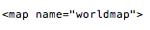Determine the coordinates of the areas that you want to map :
It can be done in three shapes which are rectangle, circle and polygon. Coordinates can be found easily by using MS-Paint.
Put all the above steps together as done in the code below.
Example1:

<!DOCTYPE html>
<html>

<h3>Mapping an Image

<body>

<p>Click on the different continents of the map to know about them.</p>

<img src="world-map-151576_960_720.png" width="960" height="492"
alt="World Map" usemap="#worldmap">

<map name="worldmap">
<area shape="rect" coords="184, 36, 272, 158" alt="north america"
href="https://en.wikipedia.org/wiki/North_America">

<area shape="rect" coords="282, 215, 354, 367" alt="south america"
href="https://en.wikipedia.org/wiki/South_America">

<area shape="rect" coords="506, 151, 570, 333" alt="africa"
href="https://en.wikipedia.org/wiki/Africa">

<area shape="rect" coords="618, 42, 791, 162" alt="asia"
href="https://en.wikipedia.org/wiki/Asia">

<area shape="rect" coords="509, 44, 593, 110" alt="europe"
href="https://en.wikipedia.org/wiki/Europe">

<area shape="rect" coords="786, 288, 862, 341" alt="australia"
href="https://en.wikipedia.org/wiki/Australia_(continent)">

<area shape="rect" coords="249, 463, 760, 488" alt="antartica"
href="https://en.wikipedia.org/wiki/Antarctica">
</map>

</body>
</html>

Example2:
<html>
<body>
<h2>Image Maps</h2>
<img src="https://cdn.pixabay.com/photo/2017/05/11/11/15/workplace-2303851_960_720.jpg" alt="Desk" usemap="#deskmap" width="500" height="380">
<map name="deskmap">
<area shape="rect" coords="175,242,420,358" alt="Keyboard" target="_blank"
href="https://en.wikipedia.org/wiki/Computer_keyboard">

<area shape="rect" coords="444,251,481,357" alt="Mouse" target="_blank" href="https://en.wikipedia.org/wiki/Computer_mouse">

<area shape="rect" coords="375,14,481,357" alt="Diary" target="_blank" href="https://en.wikipedia.org/wiki/Book">
<area shape="circle" coords="370,14,460,35" alt="Diary" target="_blank" href="https://en.wikipedia.org/wiki/Headphones">
</map>
</body>
</html>

